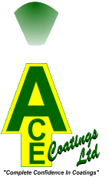
AQUATINT
WATERBASED POOL PAINT

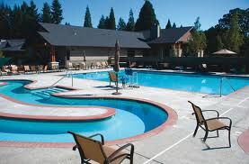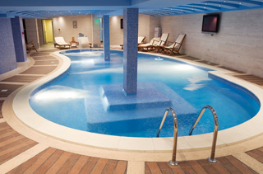

FAST APPLICATION

Dry within 2- 4 hours

FAST DRYING

Can fill pool 48 hrs after application

DURABLE

Long term protection from lime encrustation and algae

VIRTUALLY ODOURLESS
Water based product with no MSDS requirements

ACE COATINGS SOUTH LTD.
UNIT 11 SHEDDINGDEAN IND ESTATE
MARCHANTS WAY, BURGESS HILL.RH15 8QY.
VAT REG NO 982161022.REGISTERED COMPANY 7085529.
TEL /FAX NO : 01444 870087.

